**Multimedia & Graphics**

**Class Six**

**Lab 18**

|  |
| --- |
| Lab Objectives: Photo Editing |

Go to <https://www.befunky.com/create/>

Click on create and add a photo from your computer

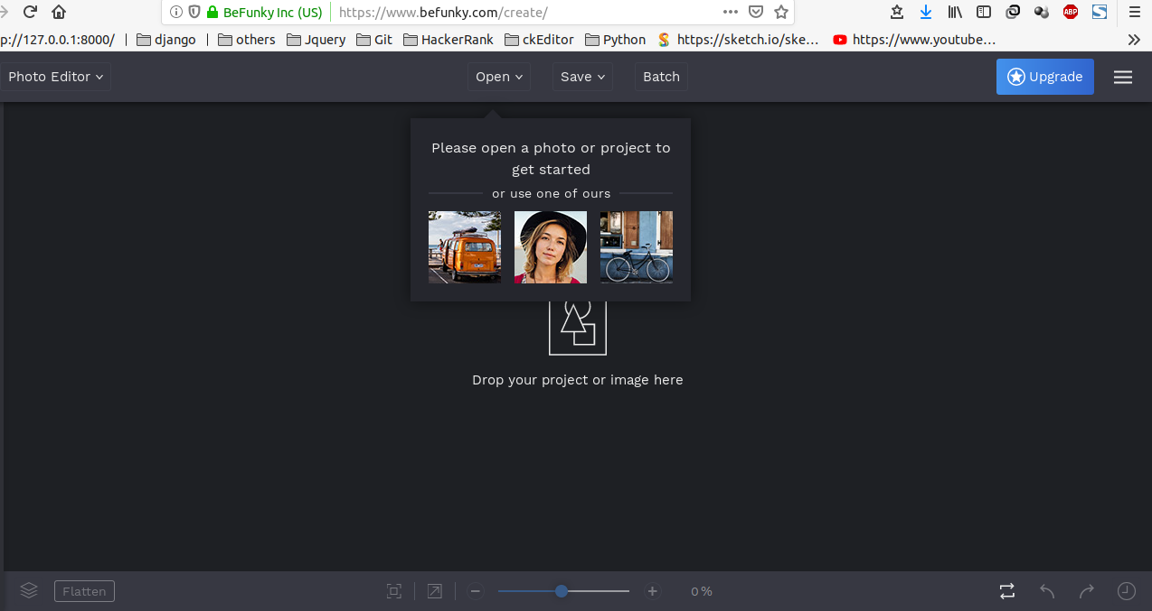

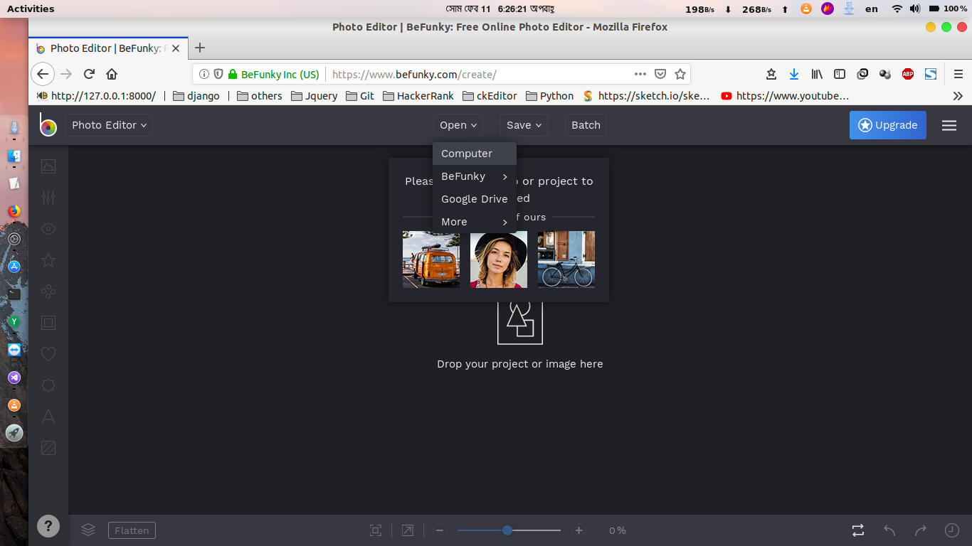

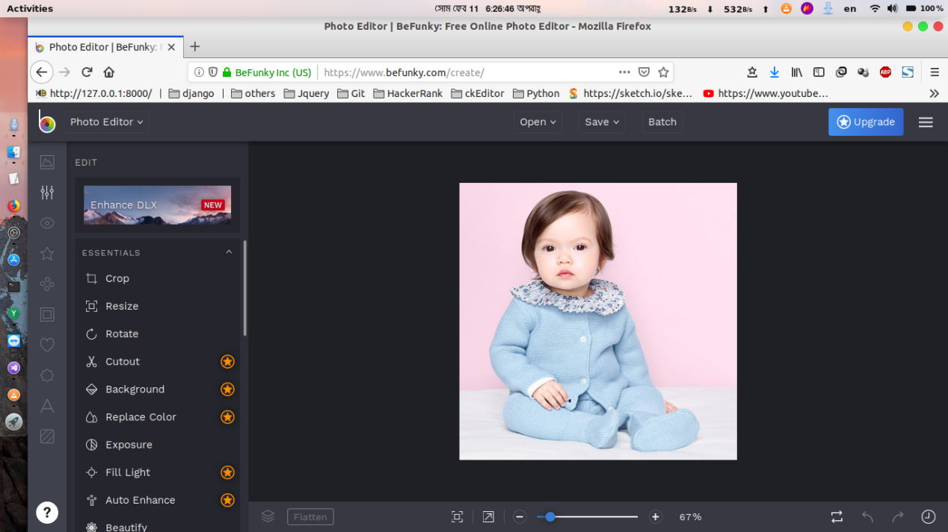

This baby picture is taken from Google. You can download any picture from Google Image search and save it to your computer and add this to befunky.com to edit.

There are lots of filter and image editing features at left bar.

We have to use this.

# Crop

To change the ratio of your image use crop function

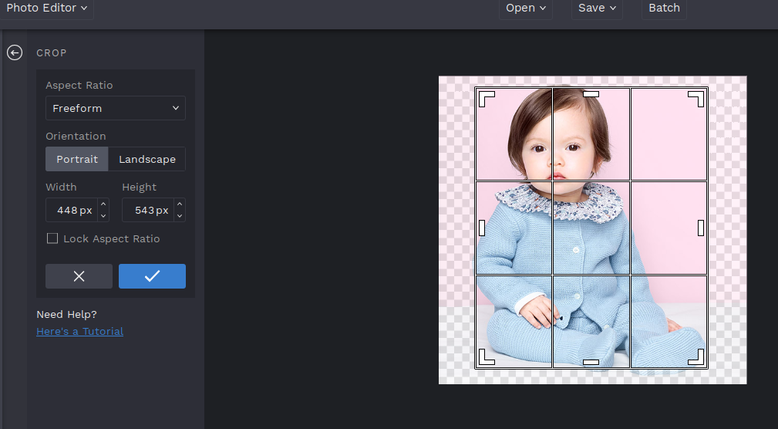

Click on tick sign to crop image

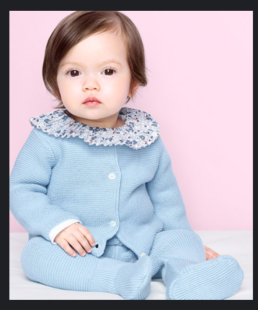

# Rotate

You can rotate the image clockwise or anticlockwise

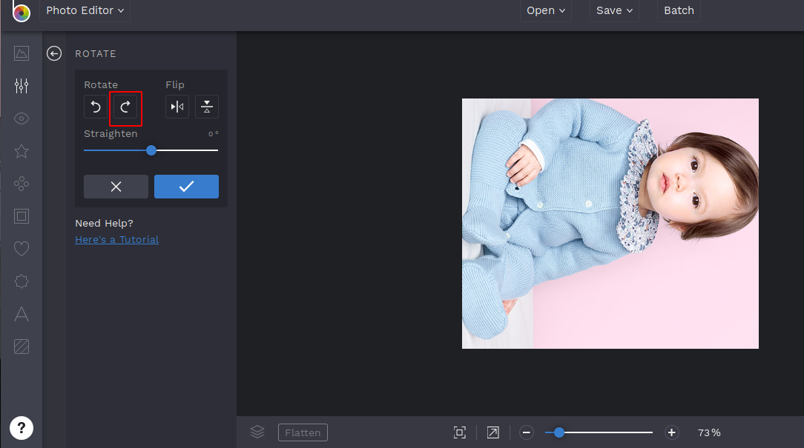

Also you can flip the image from one position to another position

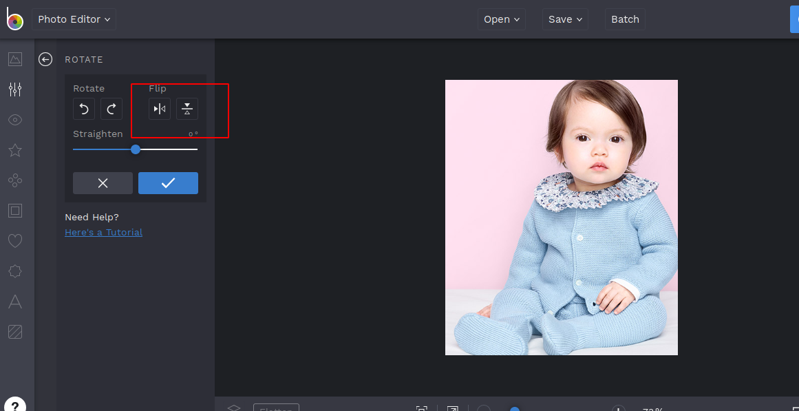

There are some star mark on the left bar. It denotes that you can not use those feature freely. You have to paid certain amount of money to use those. Let’s try about only the free features.

# Exposure

Change the Brightness, Contrast, Highlights of the image and find out how it is changing.

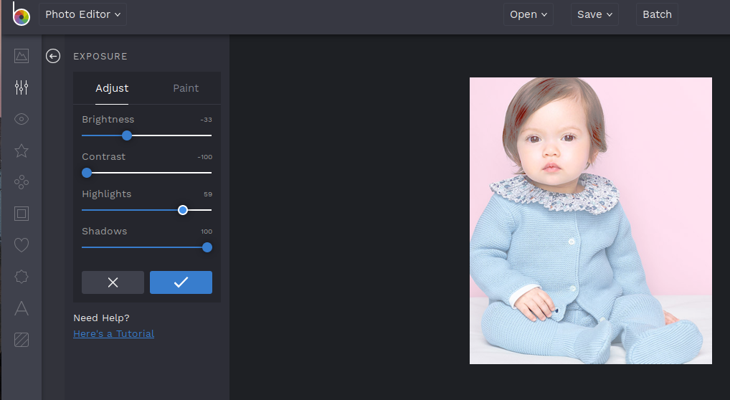

# Beautify

You can beautify your image by adjusting brush size and hardness.

Click beautify and go to paint then click on your image.

There was a light dark color over the face of that baby, We have removed this by beautify tool

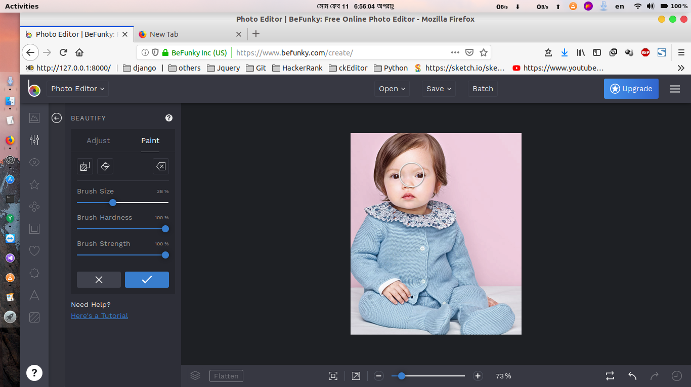

Use brush and point mouse to any place of your picture and see the magic.

# Color

You can change the whole color or the color of a specific place by using color option, Saturation, Hue, Temperature will provide you this features

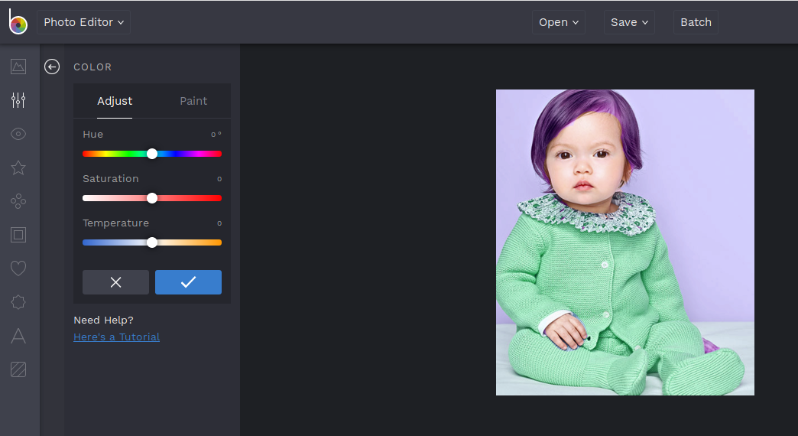

# Export

To export this image click on save as project, and store it to your computer.

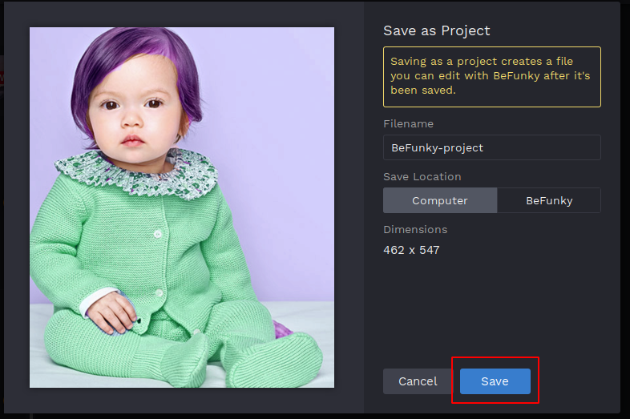

There are many more non paid features available here. Check everything and apply those to your photos.